INTERNATIONAL BURCH UNIVERSITY
FACULTY OF ENGINEERING, NATURAL AND MEDICAL SCIENCES
DEPARTMENT OF INFORMATION TECHNOLOGY



YOUR FRIENDLY NEIGHBORHOOD CHATSTER (YFNC)

UNDERGRADUATE PROJECT
Tarik Dautović

Mentor
Aldin Kovačević, STA

SARAJEVO
September, 2026
YOUR FRIENDLY NEIGHBORHOOD CHATSTER (YFNC)

Tarik Dautović

Report Submitted in Fulfillment of Requirement for the
Undergraduate Project

INTERNATIONAL BURCH UNIVERSITY
2025/2026
APPROVAL PAGE
Student name and surname: | Tarik Dautović
Faculty: | Faculty of Engineering, Natural and Medical Sciences
Department: | Information Technology
Project Title: | Your Friendly Neighborhood Chatster (YFNC)
Date of Defense: | TBA
I certify that this final work satisfies all the requirements as an undergraduate project for the bachelor's degree in information technologies.
Assoc. Prof. Dr. Dino KEČO
Head of Department
This is to certify that I have read this final work and that, in my opinion, it is fully adequate, in scope and quality, as an undergraduate project for the bachelor's degree in information technologies.
Aldin Kovačević, STA
Mentor
Examining Committee Members
 | Title / Name and Surname | Affiliation | Signature
1. | To be assigned | head
2. | To be assigned | member
3. | To be assigned | member
This final work has been approved as being written in compliance with the formatting rules laid down by the Department of Information Technology.

YOUR FRIENDLY NEIGHBORHOOD CHATSTER (YFNC)
ABSTRACT
Modern chat platforms often combine communication with dense controls and distracting secondary features. This project presents Your Friendly Neighborhood Chatster (YFNC), a full-stack web application designed for organized real-time communication and a focused user experience. The system supports account verification and recovery, friendships, direct conversations, servers and channels, message editing and deletion, replies, reactions, pins, mentions, protected attachments, read states, mute and block controls, moderation roles, real-time presence and typing indicators, and an artificial-intelligence assistant grounded in the active conversation. The application uses React and Vite on the client, Node.js, Express and Socket.IO on the server, and MySQL for persistent data. JSON Web Tokens, password hashing, resource-level permission checks, protected file routes, controlled cross-origin access, rate limiting, and security headers protect the main flows. The deployed system uses Vercel for the frontend, Railway for backend, database, and storage services, Resend for transactional email, and Gemini for assistant responses. Verification included backend unit and integration tests, frontend linting and production compilation, dependency auditing in continuous integration, and a public browser flow. All 138 backend tests passed, and the frontend completed lint and production build successfully. The result is a deployable communication platform that prioritizes clarity, practical collaboration, and continuous UI/UX improvement.

Keywords: real-time communication, chat application, web application, artificial intelligence, user experience

ACKNOWLEDGMENTS
I would like to express my sincere gratitude to my mentor, Aldin Kovačević, STA, for suggesting the project topic and for providing guidance in key areas throughout its development. His feedback, particularly the small but valuable UI/UX improvement suggestions, helped me refine the application through repeated review and practical iteration. I am also thankful to everyone who tested the system, discussed ideas with me, and supported the completion of this Senior Design Project.

DECLARATION
I hereby declare that this undergraduate project titled Your Friendly Neighborhood Chatster (YFNC) is based on my original work except for quotations and citations, which have been duly acknowledged. I also declare that this work has not previously or concurrently been submitted for any other degree at International Burch University or another institution.

Tarik Dautović
September, 2026

TABLE OF CONTENTS

1. INTRODUCTION 1
1.1. Background and Motivation 1
1.2. Problem Statement 2
1.3. Aim and Objectives 2
1.4. Project Scope and Contributions 3
1.5. Report Organization 4
2. LITERATURE REVIEW 5
2.1. Web Communication Systems 5
2.2. REST and Real-Time Transport 5
2.3. Authentication and Application Security 6
2.4. Usability and Progressive Complexity 7
2.5. Conversational Information Seeking 7
2.6. Technology Selection 8
3. SYSTEM ANALYSIS 9
3.1. System Overview 9
3.2. Stakeholders and Actors 9
3.3. Functional Requirements 10
3.4. Nonfunctional Requirements 11
3.5. Business Rules 12
3.6. Constraints and Assumptions 13
3.7. Risk Analysis 13
3.8. Feasibility and Success Criteria 14
4. APPLICATION DESIGN 15
4.1. Design Principles 15
4.2. Use-Case Model 15
4.3. Authentication Activity 16
4.4. Logical Architecture 17
4.5. Message Delivery Sequence 18
4.6. Data Model 19
4.7. Production Deployment Design 20
4.8. Interface Layout 20
5. IMPLEMENTATION 21
5.1. Development Environment and Technology Stack 21
5.2. Frontend Implementation 22
5.3. Authentication and Account Lifecycle 23
5.4. Server, Channel, and Moderation Implementation 24
5.5. Friendship, Direct Messaging, and Blocking 24
5.6. Messaging and Real-Time Synchronization 25
5.7. Attachment Handling 25
5.8. AI Chat Assistant 26
5.9. Security Controls 26
5.10. CI/CD and Production Operation 27
6. SYSTEM TESTING 28
6.1. Testing Strategy 28
6.2. Final Verification Results 29
6.3. Representative Test Cases 29
6.4. Manual UI/UX Verification 30
6.5. Limitations of Testing 30
7. MAINTENANCE ANALYSIS 31
7.1. Maintainability 31
7.2. Data Integrity and Recovery 32
7.3. Security Maintenance 32
7.4. Scaling and Availability 33
7.5. Future Improvements 33
8. CONCLUSION 35

LIST OF TABLES

Table 3.1. Stakeholders and primary interests 9
Table 3.2. Functional requirements 10
Table 3.3. Nonfunctional requirements 11
Table 3.4. Principal project risks and responses 13
Table 5.1. Implementation technology stack 21
Table 6.1. Verification methods and scope 28
Table 6.2. Final local verification results 29
Table 6.3. Representative functional and security test cases 29
Table 7.1. Maintenance areas and recommended actions 31

TABLE OF FIGURES

Figure 4.1. YFNC use-case model 15
Figure 4.2. Registration, verification, login, and recovery activity 16
Figure 4.3. Logical application architecture 17
Figure 4.4. Persistent and real-time message delivery sequence 18
Figure 4.5. Simplified entity-relationship model 19
Figure 4.6. Production deployment and service relationships 20
Figure 5.1. Direct messaging interface with navigation, conversation, composer, and profile context 22
Figure 5.2. Current-password confirmation before account deletion 23
Figure 5.3. Conversation-grounded assistant showing a concise answer 26

LIST OF ABBREVIATIONS
AI Artificial Intelligence
API Application Programming Interface
CI/CD Continuous Integration and Continuous Deployment
CORS Cross-Origin Resource Sharing
CRUD Create, Read, Update, Delete
DBMS Database Management System
DM Direct Message
HTTP Hypertext Transfer Protocol
JWT JSON Web Token
REST Representational State Transfer
SMTP Simple Mail Transfer Protocol
SQL Structured Query Language
UI/UX User Interface and User Experience
UML Unified Modeling Language
YFNC Your Friendly Neighborhood Chatster

1. INTRODUCTION

1.1. Background and Motivation
Digital communication has become part of everyday academic, professional, and personal life. People expect a messaging application to deliver messages immediately, preserve conversation history, work across devices, and provide enough structure to keep different communities and topics separated. At the same time, many mature chat products have accumulated layers of controls, promotional surfaces, automated recommendations, integrations, and secondary entertainment features. Although these additions can be useful to some users, they can also make the central activity—having a conversation—feel crowded and less direct.
Your Friendly Neighborhood Chatster, abbreviated as YFNC, was conceived as a response to that tension. The personal motivation behind the project was to explore whether a modern chat platform could offer the practical features users now expect without allowing those features to overwhelm the interface. The guiding idea was not to reproduce every capability of an established commercial platform. It was to create a focused communication environment whose navigation, visual hierarchy, and interactions remain understandable as the product grows.
This motivation shaped both the technical and design decisions. Real-time communication required a persistent connection between browser and server, while durable conversation history required a relational data model. Account verification, password recovery, permissions, private attachments, moderation, and blocking were necessary because even a student communication platform must treat identity and access as system responsibilities rather than decorative additions. The interface was then refined through small UI/UX patches, including clearer placement of controls, consistent password visibility options, simplified assistant output, and a side panel that does not interrupt the main conversation.

1.2. Problem Statement
The problem addressed by this project is the design and implementation of a complete web-based chat application that supports reliable real-time communication, organized group spaces, private conversations, secure account management, and useful assistant features while remaining visually focused. Solving only the messaging portion would not be sufficient. A useful system also has to answer questions such as who is permitted to view a message, how a user recovers an account, what happens when a connection is lost, how unread state is calculated, how an uploaded file is protected, and how deployment behaves when the frontend and backend are hosted separately.
The project therefore treats communication as a coordinated set of client, server, database, email, storage, and artificial-intelligence responsibilities. The client must present immediate feedback and maintain a clear state. The backend must validate each request, enforce authorization, write consistent records, and broadcast appropriate events. The database must preserve relationships between users, conversations, memberships, messages, reactions, attachments, and read states. External services must be integrated without exposing secrets or weakening the application’s own permission rules.

1.3. Aim and Objectives
The primary aim is to develop and deploy a full-stack communication platform that demonstrates secure account management, real-time text communication, organized group and direct messaging, responsible moderation, and a clean user experience. The completed project is expected to function as a coherent product rather than as a collection of disconnected demonstrations.
• Design an interface that keeps the active conversation central and places secondary tools in predictable locations.
• Implement registration, email verification, authentication, profile editing, password recovery, and account deletion.
• Support servers, channels, memberships, roles, invitations, moderation, friendships, direct conversations, and blocking.
• Deliver messages and presence-related updates in real time while persisting durable state in MySQL.
• Provide replies, edits, deletions, reactions, pins, mentions, attachments, search, unread state, and mute controls.
• Add an assistant that can answer natural-language questions about the active chat while exposing only a concise answer in the interface.
• Apply layered security controls and verify the system through automated tests, static checks, builds, audits, and browser flows.
• Deploy the application through a reproducible CI/CD workflow and document its present scaling boundary.

1.4. Project Scope and Contributions
YFNC covers the complete path from account creation to sustained communication. Public users can register, verify an email address, sign in, request a new verification message, and recover a forgotten password. Authenticated users can maintain a profile, build a friend network, create or join servers, organize channels, begin direct conversations, and control unwanted contact. Message interactions include text, attachments, replies, editing, deletion, reactions, pins, mentions, search, read markers, and unread indicators. Server owners and administrators can manage memberships and bans according to role-based rules.
The project’s main contribution is the integration of these capabilities into one deployable system with a deliberately restrained interface. It also demonstrates a practical conversation-grounded assistant. Rather than presenting model diagnostics, sources, or internal selection details, the interface shows the user’s question and the assistant’s answer in a compact side panel. This decision reflects the overall design goal: advanced functionality should remain available without dominating the conversation.

1.5. Report Organization
The remainder of this report follows the structure of the official Senior Design Project template. Chapter 2 reviews concepts and prior work relevant to web communication, real-time transport, security, usability, and conversational information seeking. Chapter 3 analyzes stakeholders, requirements, risks, and feasibility. Chapter 4 presents structural and behavioral design models. Chapter 5 explains the implementation and deployed environment. Chapter 6 reports verification results. Chapter 7 discusses maintenance, integrity, security, constraints, and future work. Chapter 8 concludes the report and reflects on the knowledge gained during development.

2. LITERATURE REVIEW

2.1. Web Communication Systems
A browser-based messaging system combines characteristics of an information system and an interactive communication medium. The application must preserve durable records, yet it must also react quickly enough that participants perceive an ongoing conversation. This combination distinguishes chat from a conventional content website. A page can no longer be treated as a static response to a request; it becomes a synchronized view of a shared and continuously changing state.
Conversation organization is equally important. Direct conversations are naturally centered on a small set of participants, whereas group communities require membership, roles, channels, invitations, moderation, and topic separation. A relational database is well suited to this structure because users, memberships, conversations, messages, reactions, and attachments have explicit relationships and integrity rules. The YFNC schema uses separate associative tables where relationships have their own state, such as a member’s server role or a participant’s last-read message.

2.2. REST and Real-Time Transport
Representational State Transfer provides a useful architectural model for resource-oriented web APIs. Fielding (2000) describes constraints that support separation between client and server and enable components to evolve independently. YFNC applies this approach to operations such as authentication, server management, message history, search, uploads, and profile updates. HTTP endpoints provide validation, durable writes, predictable status codes, and a straightforward surface for integration testing.
HTTP request-response interaction alone is less suitable for events that should appear immediately. The WebSocket protocol establishes full-duplex communication over a single connection (Fette & Melnikov, 2011). Socket.IO builds practical reconnection, event, and room abstractions on top of transports that support real-time browser communication. YFNC therefore combines REST endpoints for resource operations with an authenticated Socket.IO connection for presence, typing, message updates, reactions, pins, membership changes, and other live events. This hybrid avoids forcing one communication mechanism to solve every problem.

2.3. Authentication and Application Security
Security begins with the assumption that browser input and network requests cannot be trusted. JSON Web Tokens provide a compact representation of signed claims (Jones, Bradley, & Sakimura, 2015), but a token is useful only when the server validates its signature, expiry, and intended use. Password storage requires a deliberately expensive one-way function. The adaptive password-scheme principle described by Provos and Mazières (1999) supports increasing computational cost as hardware improves; the application applies bcrypt-based hashing rather than storing recoverable passwords.
Authentication does not replace authorization. A valid user may still be prohibited from entering a server, reading a direct conversation, downloading an attachment, editing another person’s message, or assigning a protected role. The OWASP Application Security Verification Standard emphasizes systematic verification across authentication, access control, input handling, stored data, and communications. In YFNC, authorization is repeated at the route and resource level. Private files are served through protected application routes instead of being exposed as a public directory, and cross-origin access is restricted to configured frontend origins.

2.4. Usability and Progressive Complexity
Usability in a communication product is affected by frequency and interruption. Sending a message, changing conversations, checking unread state, or identifying who is speaking happens repeatedly; even small friction is multiplied across a session. A clear layout should therefore establish stable regions for navigation, conversation content, context, and composition. Destructive actions must be distinct, confirmation steps must explain their consequence, and small controls such as password visibility toggles should behave consistently wherever a user enters a password.
The project adopts progressive complexity as a design principle. Common actions remain visible, while contextual actions appear near the object they affect. The assistant opens from the side so that the current conversation remains spatially stable. Its response shows only the final answer, because model identifiers, context-count messages, and evidence cards can distract a user whose immediate goal is to obtain information. This is an example of simplifying presentation without reducing underlying capability.

2.5. Conversational Information Seeking
Conversational information seeking studies how users express information needs through natural language and iterative interaction. Radlinski and Craswell (2017) argue that conversational search should be evaluated as an interaction rather than as a single ranked result. Zamani et al. (2023) further describe a broad research space that connects retrieval, dialogue, generation, evaluation, and user modeling. These ideas are relevant to chat archives because users often remember the intent of a discussion but not the exact wording needed for keyword search.
YFNC limits the assistant’s context to messages the authenticated user is already permitted to view. The server selects conversation evidence, prepares it for the configured provider, and returns an answer associated with the current chat. This retrieval-grounded approach reduces dependence on general model memory and makes the assistant useful for questions about appointments, decisions, tasks, files, and plans discussed inside a conversation. The interface intentionally hides implementation metadata, but the backend retains provider boundaries and configurable context limits so that the feature can evolve.

2.6. Technology Selection
React was selected for component-based interface construction and predictable state-driven rendering. Vite provides a fast development server and a compact production build process. Node.js and Express allow the API and real-time layer to use the same primary language as the client, while Socket.IO supplies authenticated events, rooms, reconnection behavior, and acknowledgments. MySQL provides transactions, constraints, indexing, and established operational tooling. Jest and Supertest support backend testing, Selenium exercises a browser-level path, and GitHub Actions provides repeatable verification on changes to the main branch.
The review of these concepts led to an architecture in which responsibilities are explicit: REST for durable resource actions, sockets for time-sensitive delivery, relational storage for integrity, external services for email and language-model capabilities, and a React interface that keeps those mechanisms behind familiar user actions. The following analysis translates that foundation into concrete system requirements.

3. SYSTEM ANALYSIS

3.1. System Overview
YFNC is a standalone web communication platform implemented with a client-server architecture. The browser client renders the interface and maintains interactive state. The backend exposes HTTP resources, authenticates the real-time connection, applies business rules, and coordinates external services. MySQL stores durable application data, while a persistent backend volume stores uploaded files whose access is checked by the application. This separation allows the frontend and backend to be deployed independently while still presenting one product to the user.
The system supports two complementary communication contexts. Servers contain members and channels and are appropriate for communities or topic-based discussion. Direct conversations support private communication between friends. Both contexts share common message concepts, including replies, attachments, reactions, pins, unread status, editing, deletion, and search, while retaining separate authorization and lifecycle rules.

3.2. Stakeholders and Actors

Table 3.1. Stakeholders and primary interests
Stakeholder | Role | Primary interests
Visitor | Unauthenticated actor | Registration, verification, login, password recovery, understandable public forms
Registered user | Primary system actor | Reliable messaging, privacy, organized navigation, profile and notification controls
Server owner | Creates and governs a server | Channel structure, invitations, membership, role assignment, bans
Server administrator | Delegated moderator | Day-to-day membership and content management within assigned authority
Project administrator | Deployment and maintenance actor | Availability, configuration, database integrity, logs, backups, safe releases
Mentor and committee | Academic evaluators | Traceable requirements, engineering justification, verification evidence, documentation quality

3.3. Functional Requirements

Table 3.2. Functional requirements
ID | Requirement | Acceptance statement
FR-01 | Account registration | A visitor can register with a unique username and email address and a policy-compliant password.
FR-02 | Email verification | The system issues, validates, expires, and can resend an account-verification token.
FR-03 | Authentication | A verified user can sign in and receive a signed access token.
FR-04 | Password recovery | A user can request a reset email and select a new password through a time-limited token.
FR-05 | Profile management | An authenticated user can update profile fields and avatar information.
FR-06 | Account security | A user can change a password or permanently delete the account after current-password confirmation.
FR-07 | Friend network | Users can send, accept, reject, list, and remove friend relationships.
FR-08 | Blocking | A user can block, unblock, and list blocked users, with contact restrictions applied consistently.
FR-09 | Server lifecycle | A user can create, view, update, and delete an authorized server.
FR-10 | Channel lifecycle | Authorized members can create, update, reorder, and delete channels.
FR-11 | Invitations | Authorized members can create, list, and use server invitations.
FR-12 | Membership | Members can list participants and leave; authorized roles can remove or ban participants.
FR-13 | Roles | Owners can assign protected server roles subject to hierarchy rules.
FR-14 | Server messages | Members can send and retrieve channel messages with real-time delivery.
FR-15 | Direct conversations | Friends can create and use private conversations with authorized participants only.
FR-16 | Message lifecycle | Authors or permitted moderators can edit and delete messages according to context.
FR-17 | Replies and mentions | Users can reply to a message and mention relevant participants.
FR-18 | Reactions | Users can add or remove emoji reactions with synchronized counts.
FR-19 | Pins | Authorized participants can pin and unpin important messages.
FR-20 | Attachments | Users can upload and download permitted message attachments through protected routes.
FR-21 | Search | Users can search accessible message history within the active context.
FR-22 | Read state | The system records last-read state and presents unread indicators.
FR-23 | Mute controls | Users can mute servers, channels, and direct conversations independently.
FR-24 | Presence and typing | Connected users receive appropriate online and typing updates in real time.
FR-25 | Chat assistant | Users can ask questions about an accessible channel or direct conversation and receive a concise grounded answer.

3.4. Nonfunctional Requirements

Table 3.3. Nonfunctional requirements
ID | Quality | Requirement
NFR-01 | Security | Passwords are hashed; tokens expire; authorization is resource-scoped; private files are not publicly exposed.
NFR-02 | Performance | Common messaging actions provide immediate UI feedback and real-time delivery under the intended single-instance load.
NFR-03 | Reliability | Durable actions are stored in MySQL and connection recovery does not create duplicate persistent records.
NFR-04 | Usability | Primary navigation and composer actions remain discoverable, consistent, responsive, and keyboard accessible where applicable.
NFR-05 | Maintainability | Client, routes, services, socket handlers, database access, and tests remain separated by responsibility.
NFR-06 | Portability | The web client operates in current desktop browsers and the services are configured through environment variables.
NFR-07 | Deployability | Pushes to the main branch run automated verification and produce deployable frontend and backend artifacts.
NFR-08 | Privacy | Conversation data and attachments are returned only after authentication and participant or membership checks.

3.5. Business Rules
A username and email address must remain unique. An unverified account cannot use the full authenticated application. Friendships are symmetrical even though a request has a sender and receiver. A direct conversation is visible only to its participants, and a server channel is visible only to an eligible member. A member cannot assign a role at or above the member’s own authority, and an owner has protections that prevent accidental removal through lower-level actions. A user who is blocked cannot use the normal friendship or direct-contact flow to bypass that decision.
Message operations are contextual. An author can modify the author’s own content, while a moderator may have additional deletion authority in a server. Reactions are unique per user, message, and emoji. Pin state is represented explicitly so that it can be synchronized and listed. Read state advances rather than moving backward. Attachments inherit the authorization of the message to which they belong. Assistant requests use only content the requesting user is already permitted to retrieve.

3.6. Constraints and Assumptions
The current production architecture intentionally targets one backend application instance. Rate-limit state and active Socket.IO connection tracking are held in process memory, so starting several independent backend instances would produce inconsistent enforcement and presence behavior. Horizontal scaling therefore requires a shared rate-limit store, a Socket.IO multi-instance adapter with publish-subscribe infrastructure, and shared object storage. This boundary is documented rather than hidden because maintainers must understand it before changing deployment topology.
Additional constraints include the availability and limits of the email and AI providers, browser network quality, database capacity, and persistent-volume management. The project assumes modern JavaScript support and HTTPS in production. It also assumes that provider secrets are supplied only through protected deployment configuration and are never embedded in the browser bundle or source repository.

3.7. Risk Analysis

Table 3.4. Principal project risks and responses
Risk | Impact | Likelihood | Response
Unauthorized resource access | High | Medium | Central authentication, repeated participant/member checks, role rules, protected file routes, tests
Message state inconsistency | High | Medium | Persist before broadcasting, stable identifiers, scoped rooms, refetch/reconnection paths
External provider outage | Medium | Medium | Clear error handling, configuration boundaries, provider-independent core messaging
Attachment storage loss | High | Low–Medium | Persistent volume, metadata in MySQL, backup and restoration procedure
Interface complexity growth | Medium | High | Progressive disclosure, design review, small UI/UX patches, responsive testing
Secret exposure | High | Low | Environment configuration, repository exclusion, deployment secret management
Insufficient automated coverage | Medium | Medium | Jest/Supertest suites, lint, build, browser flow, CI checks, regression additions
Premature horizontal scaling | High | Low | Document single-instance limit and required Redis/adapter/shared-storage work

3.8. Feasibility and Success Criteria
The project is technically feasible because its components are mature, documented, and suitable for a real-time web application. It is operationally feasible because users need only a browser and an email address, while deployment services provide managed environments for the frontend, backend, database, and email delivery. It is economically feasible for an academic deployment because development tooling is open source and the selected hosted services support modest workloads without specialized hardware.
Success is defined by an end-to-end flow rather than by isolated screens. A user must be able to establish an account, enter the application, connect with another user, organize a group or direct context, exchange and manage messages, receive live state updates, control unwanted contact, and return later to preserved history. The deployed application must pass automated verification, keep sensitive configuration outside source code, and clearly disclose operational limits. These criteria are reflected in the implementation and test results presented later in the report.

4. APPLICATION DESIGN

4.1. Design Principles
The application design is guided by separation of concerns, least privilege, a single source of durable truth, immediate interaction feedback, and progressive disclosure. The browser is responsible for presentation and transient interaction state; the server is authoritative for permissions and persisted actions; the database enforces relationships and constraints; external providers are accessed only through backend service boundaries. Features are placed according to frequency and context so that adding capability does not require filling the main conversation with permanent controls.

4.2. Use-Case Model
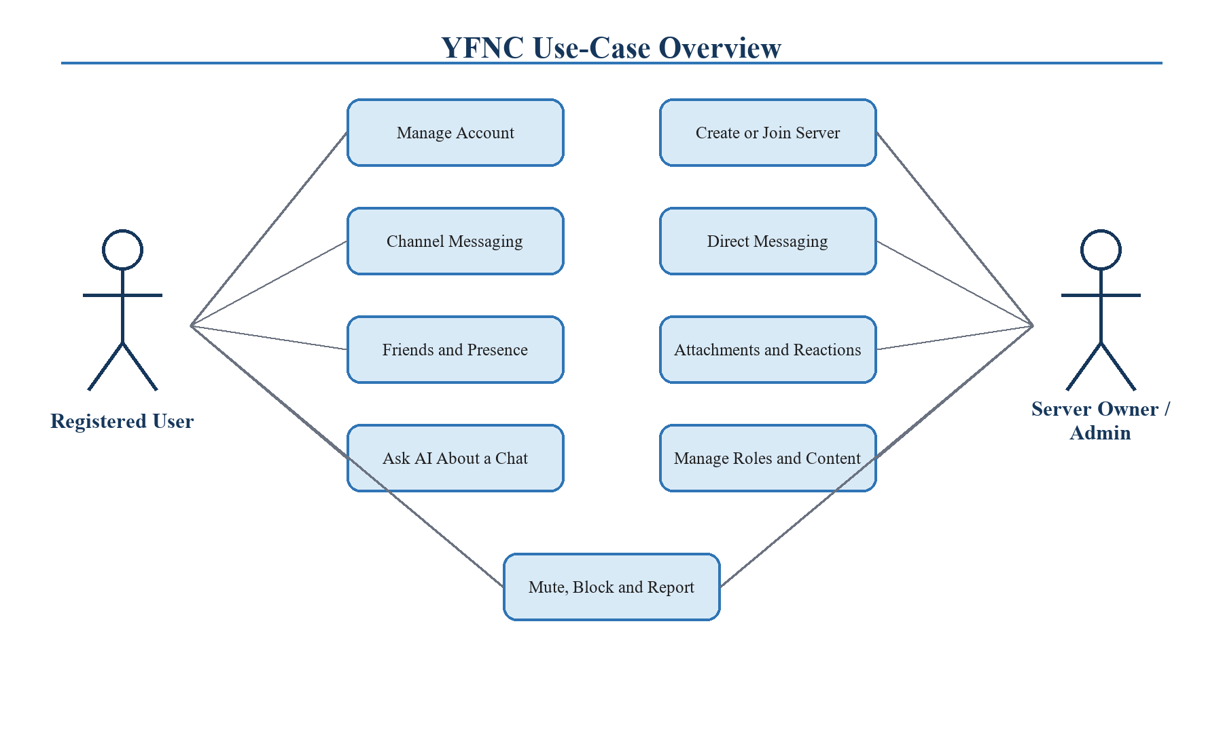

Figure 4.1. YFNC use-case model
Figure 4.1 summarizes the major interactions. A visitor is limited to the identity-entry flows. A registered user gains communication and personal-control capabilities. Server administrators receive delegated membership and moderation operations, while the server owner retains protected ownership and role-management authority. External email and AI services support specific use cases but do not become application actors with independent access to the database.

4.3. Authentication Activity
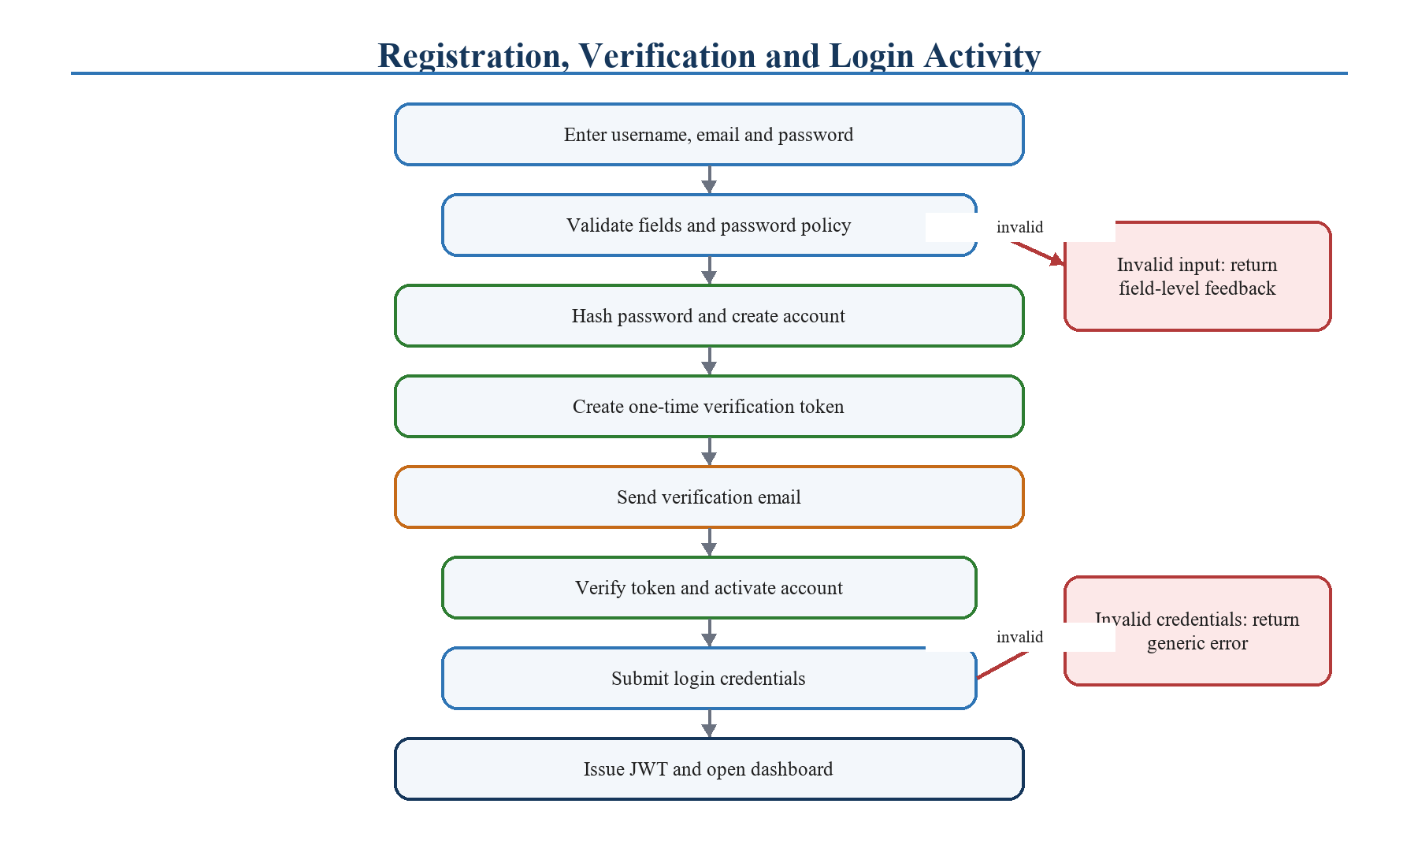

Figure 4.2. Registration, verification, login, and recovery activity
The identity activity begins with validated registration data and continues through email verification before normal access is granted. Login checks the stored password hash and verification state before issuing an access token. Recovery uses a separate expiring token so that a forgotten password does not weaken the login path. Current-password confirmation protects high-impact authenticated operations such as password changes and account deletion.

4.4. Logical Architecture
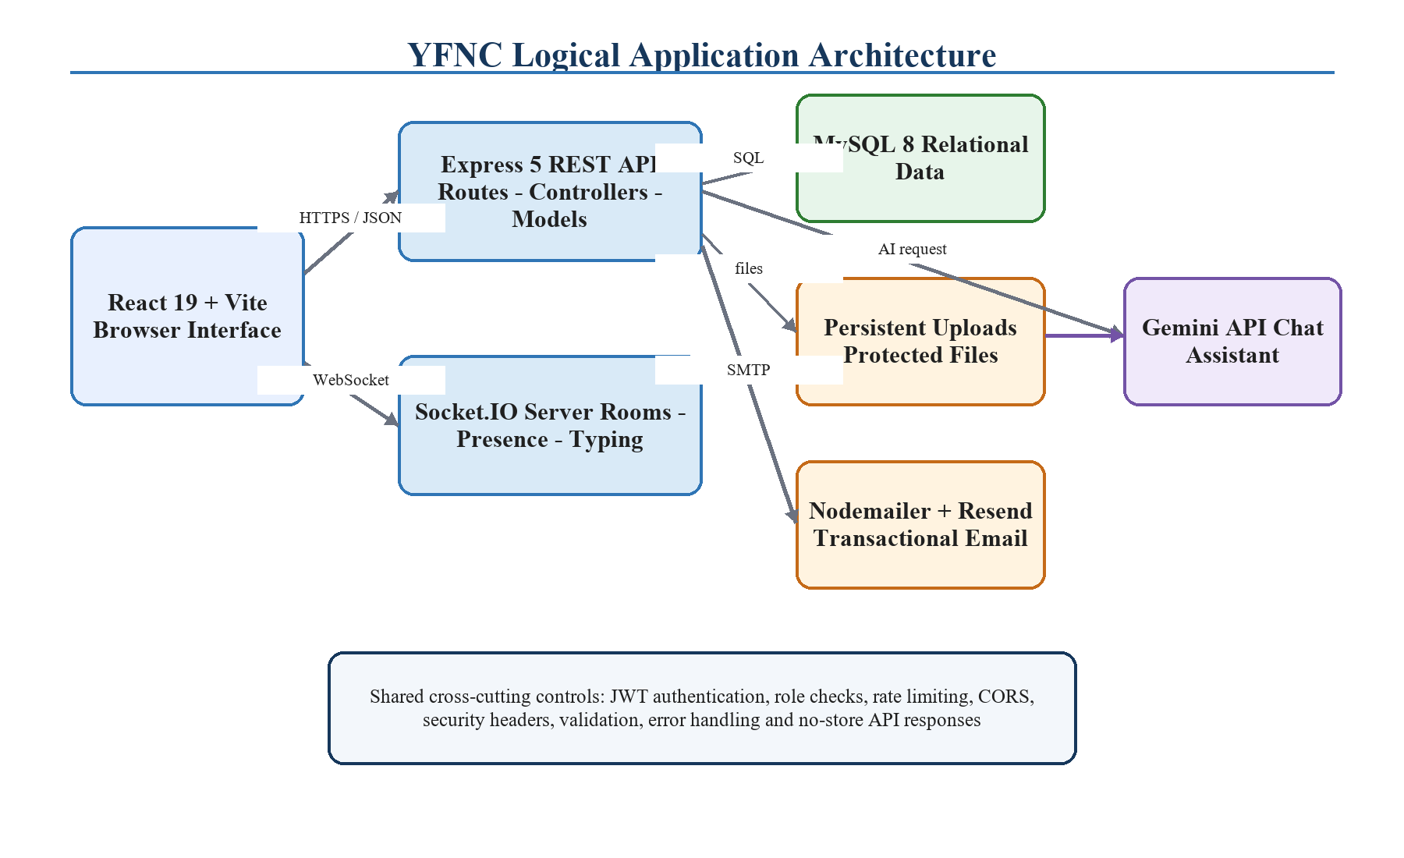

Figure 4.3. Logical application architecture
The logical architecture separates the React user interface from the Express routes and Socket.IO event handlers. HTTP middleware performs parsing, authentication, cross-origin checks, security headers, and rate control before a route reaches domain logic. Socket authentication establishes an identity before the connection joins user, conversation, or channel rooms. Both paths reuse database and service modules rather than applying independent definitions of the same permission.
Email and assistant providers are called from the backend. This prevents private keys from being delivered to the browser and allows provider-specific response formats to be converted into application-level results. Attachment metadata is stored in MySQL while file bytes remain on persistent storage. Download routes first locate the message relationship and then verify that the requester is an eligible participant or member.

4.5. Message Delivery Sequence
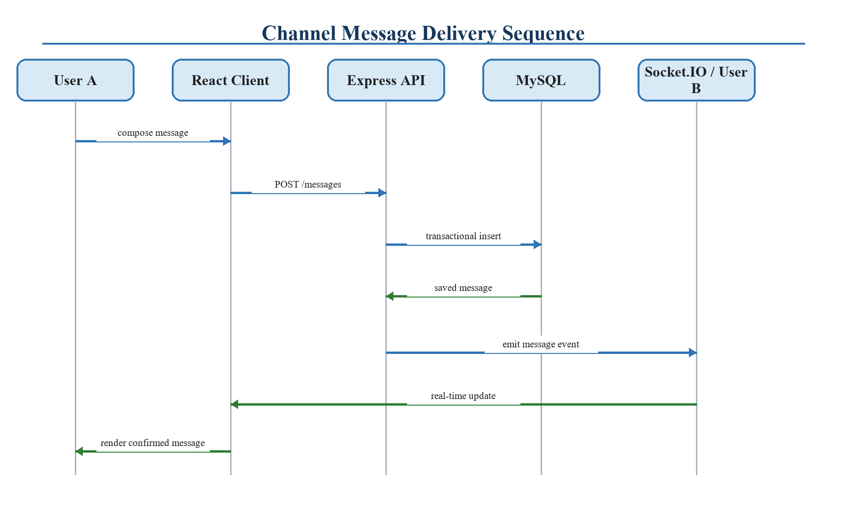

Figure 4.4. Persistent and real-time message delivery sequence
A message begins as a user action in the composer. The client submits the content and any attachment metadata to an authenticated endpoint. The backend validates size, type, context, membership, and blocking constraints, then stores the message and related records. Only after a durable identifier exists does the server emit the event to the correct room. Each client can then merge the confirmed record into local state and update unread or read information. This order makes the database the authoritative source and reduces phantom messages that were broadcast but not saved.

4.6. Data Model
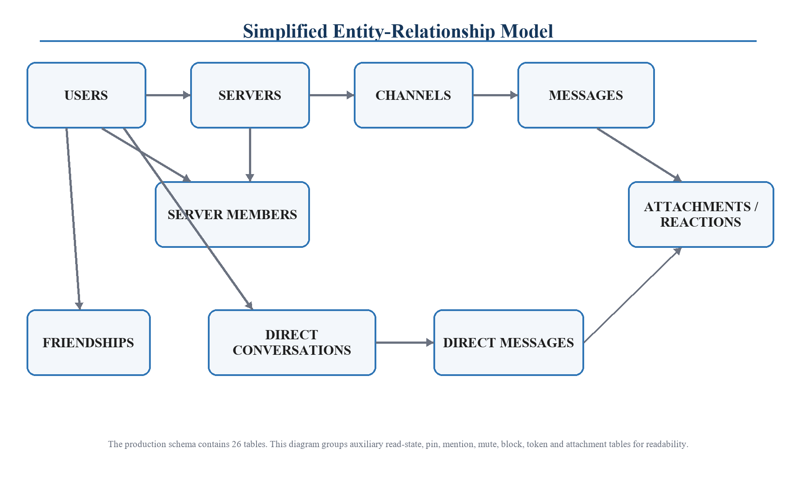

Figure 4.5. Simplified entity-relationship model
The production schema contains 26 tables. Figure 4.5 groups auxiliary entities so that the central relationships remain readable. Users own servers and participate in them through server_members, where role and membership state belong. Servers contain channels, and channels contain messages. Users also participate in direct conversations and create direct messages. Attachments, reactions, pins, mentions, read states, mute preferences, deletion markers, blocks, invitation records, and verification tokens are represented separately because each has a distinct lifecycle or uniqueness rule.
Foreign keys preserve ownership and context. Unique constraints prevent duplicate friendships, duplicate per-user reactions, or conflicting membership records. Indexes support common lookups such as ordered message history, unread calculations, active invitations, and participant-based conversation discovery. Separating server messages and direct messages avoids forcing different authorization and deletion semantics into one overloaded table while allowing the service layer to expose similar interface behavior.

4.7. Production Deployment Design
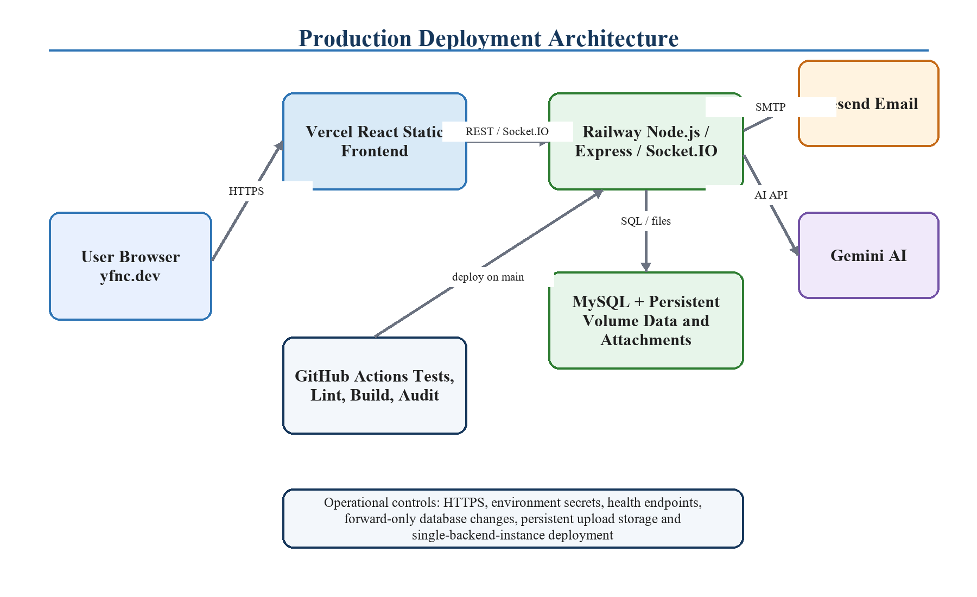

Figure 4.6. Production deployment and service relationships
The public frontend is delivered by Vercel at yfnc.dev. It communicates over HTTPS with the Railway-hosted Node.js service, which exposes both the API and the real-time Socket.IO endpoint. Railway also provides the MySQL service and a persistent storage volume for protected uploads. Resend delivers account emails and Gemini provides assistant responses. GitHub is the source of truth for releases; changes to the main branch run automated checks and trigger the configured deployment workflow.

4.8. Interface Layout
The desktop layout uses stable vertical regions: workspace navigation, conversation navigation, the message area, and an optional context panel. The composer remains at the bottom of the active conversation. Search and contextual controls appear in the conversation header. The AI control and mute control are ordered deliberately, and the AI experience opens laterally like a browser side panel. This preserves the conversation’s vertical position and gives users a predictable way to enter and leave the feature.
Responsive behavior retains access to the active conversation and composer while supporting regions collapse or reorder. Consistent colors, focus states, and controls let continued UI/UX improvements build on the same visual system.

5. IMPLEMENTATION

5.1. Development Environment and Technology Stack

Table 5.1. Implementation technology stack
Layer | Technology | Responsibility
Frontend | React 19, Vite, React Router, Socket.IO Client, CSS | Component rendering, routing, forms, state, responsive layout, real-time event consumption
Backend | Node.js 22.12, Express 5, Socket.IO | API routing, middleware, business rules, real-time rooms and events, provider integration
Database | MySQL 8 / InnoDB | Persistent identities, communities, conversations, messages, relationships and interaction state
Files | Multer and persistent backend volume | Validated uploads with metadata and authorization-controlled downloads
Email | Nodemailer with Resend SMTP | Verification and password-recovery messages
Assistant | Gemini API with provider abstraction | Answers grounded in accessible messages from the active chat
Quality | Jest, Supertest, Selenium, ESLint, npm audit | Automated verification from module behavior to public browser flow
Delivery | Git, GitHub Actions, Vercel, Railway | Version control, CI checks, frontend and backend production deployment

The project is organized into frontend and backend applications with separate dependency manifests and scripts. Environment-specific values are provided through configuration rather than hard-coded into components. A pinned Node.js version makes local development and continuous integration more reproducible. The OpenAPI description documents the HTTP surface, while README and deployment guidance explain setup, production health checks, storage expectations, and the current scaling limitation.

5.2. Frontend Implementation
The React client maps application responsibilities to reusable pages and components. Public routes handle registration, verification, login, and recovery. Authenticated routes load the current user, navigation state, conversations, servers, channels, and permissions. Forms keep local values and validation feedback, while server data is refreshed or updated in response to successful API requests and socket events. Protected routing prevents the main interface from rendering as if a missing or expired session were valid.
The interface uses ordinary CSS rather than a large component framework. This provided direct control over spacing, responsive behavior, and the dark visual theme. Repeated patterns—buttons, inputs, cards, dialogs, status indicators, avatars, and panel headers—share consistent dimensions and interaction states. Password fields provide visibility toggles in the registration, login, recovery, change-password, and destructive-confirmation contexts so that the behavior is predictable instead of appearing in only one form.
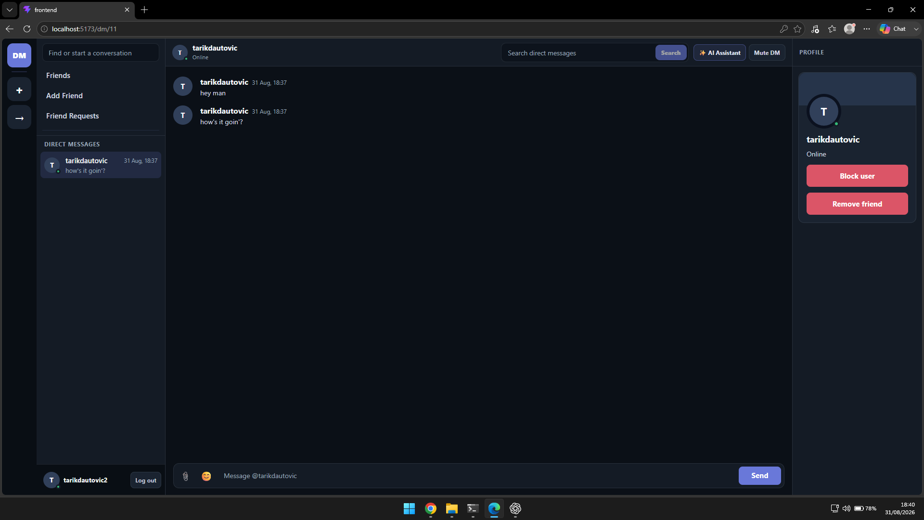

Figure 5.1. Direct messaging interface with navigation, conversation, composer, and profile context
Figure 5.1 shows the primary direct-message workspace. The conversation remains the largest region, while global navigation, the direct-message list, search, communication controls, and user context occupy stable supporting areas. The composer stays anchored below message history. This arrangement makes the product usable without requiring the user to reopen basic navigation on every action.

5.3. Authentication and Account Lifecycle
Registration validates the submitted username, email, and password before creating the account and a verification token. Transactional email is sent through the backend, which keeps SMTP credentials private. Verification consumes a purpose-specific expiring token. Login compares the submitted password to the stored bcrypt hash and issues a signed JWT only when account conditions are satisfied. Authenticated requests then use centralized token middleware to establish the user identity.
Password recovery deliberately does not reveal sensitive account details through the interface. A reset token has a limited lifetime and can be consumed to replace the stored hash. Changing a password and deleting an account require the current password, protecting users from an unattended authenticated session. Account deletion is presented as a distinct destructive action with a confirmation dialog, illustrated in Figure 5.2.
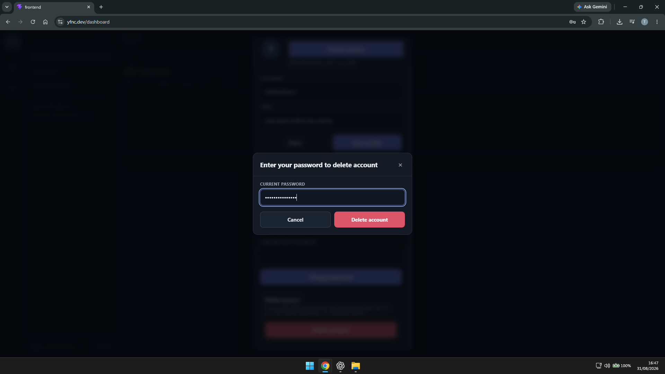

Figure 5.2. Current-password confirmation before account deletion

5.4. Server, Channel, and Moderation Implementation
Server creation records the owner as a protected member. Channel operations check membership and role authority. Invitations connect a shareable token to a server and apply validity rules before membership is created. Owners and administrators can inspect members and apply actions within a role hierarchy; leaving, removal, banning, unbanning, and role updates are separate operations so that each can enforce the correct preconditions and produce a specific audit trail in application behavior.
The role model uses owner, administrator, and member responsibilities. An administrator can perform delegated moderation but cannot silently replace or remove the protected owner. Ban checks are applied when a user attempts to rejoin. Socket rooms reflect server and channel membership so that events are delivered only to relevant connections, while the HTTP endpoint repeats the permission check before a durable change occurs.

5.5. Friendship, Direct Messaging, and Blocking
Friend requests preserve direction until accepted or rejected. Acceptance creates the durable relationship used for normal direct-conversation discovery. Direct conversations maintain participant records and independent read, mute, pin, reaction, attachment, and deletion state. A user may remove a friendship without corrupting existing historical records. Blocking is treated as a stronger control and is checked in contact-oriented operations so that a blocked user cannot recreate the same interaction through another normal endpoint.
Direct-conversation deletion is represented per user rather than by destructively removing history for every participant. This supports a familiar experience in which one user can clear a conversation from personal navigation without rewriting the other participant’s view. New activity can be handled according to the application’s conversation lifecycle rules while durable message ownership remains intact.

5.6. Messaging and Real-Time Synchronization
Server and direct messages share interface behaviors but use context-specific backend routes and tables. The server validates content, authorization, reply targets, attachments, and applicable block or membership state. Successful records receive database identifiers and timestamps before real-time notification. Editing and deletion produce scoped events that allow connected clients to update the matching item instead of reloading the full conversation.
Reactions have uniqueness rules that prevent the same user from adding the same emoji repeatedly. Pins create explicit records so that pinned messages can be listed and synchronized. Mentions are extracted into separate records for targeted retrieval. Read-state tables record progress through a conversation and support unread indicators. Mutes are stored per user and context, allowing a user to quiet a server, channel, or direct conversation without changing another participant’s experience.
The Socket.IO server authenticates the connection and associates it with user-specific and conversation-specific rooms. Presence and typing events are transient and therefore do not require the same persistence as messages. Reconnection logic restores room membership and allows the client to refresh durable state from HTTP endpoints. The production design currently uses one backend instance so that process-local connection tracking remains coherent.

5.7. Attachment Handling
Uploads are processed by Multer with configured size and type restrictions. The database stores message-to-file metadata, while file bytes are placed on persistent storage. The upload directory is not exposed as an unrestricted static website. A download request identifies the attachment and its parent message, authenticates the requester, checks the requester’s membership or participation, and only then returns the file. This design prevents knowledge of a filename from becoming authorization.

5.8. AI Chat Assistant
The assistant is implemented behind authenticated channel and direct-message endpoints. The backend selects relevant messages from a context the requester is allowed to read, constructs a grounded prompt, and calls the configured provider. Gemini 2.5 Flash is the default production model, while the service boundary allows local or alternative provider configurations. Limits on context and output protect responsiveness and provider usage.
The visible experience was refined after implementation. Introductory marketing text, sample-question chips, source cards, provider labels, and counts of examined messages were removed. The panel now displays the user’s question and only the assistant’s answer. The user label and assistant icon are aligned with their respective messages, the input and action button share a balanced layout, and the panel enters from the side rather than expanding from the top. Figure 5.3 presents the resulting compact interaction.
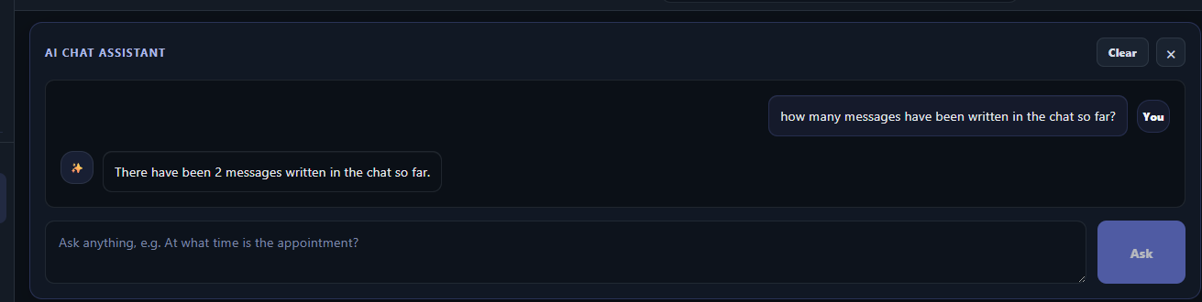

Figure 5.3. Conversation-grounded assistant showing a concise answer

5.9. Security Controls
The backend removes the default framework-identification header and applies content-type, framing, referrer, feature-permission, and production transport-security headers. CORS uses an explicit origin allowlist. API responses that contain private state are marked to avoid inappropriate caching. Trust-proxy behavior is explicitly configured for the deployment environment rather than enabled without bounds. Rate limiting protects sensitive endpoints, while input validation and parameterized database access reduce malformed-input and injection risk.
Authorization is defense in depth. The frontend hides unavailable actions to improve usability, but the backend never treats that as a security boundary. Server membership, conversation participation, role authority, ownership, message authorship, and block state are checked where the action is performed. Secrets, database credentials, SMTP configuration, signing keys, allowed origins, and provider keys are supplied through the environment. No credential is required in the public frontend bundle.

5.10. CI/CD and Production Operation
GitHub Actions runs on changes to the main branch and on pull requests. The backend workflow verifies configuration, executes Jest tests, and performs an audit. The frontend workflow runs ESLint, creates the production build, and performs its audit. A failed required step prevents the change from being treated as a verified release. Successful changes are deployed through Vercel and Railway. Separate liveness and readiness endpoints, graceful shutdown, frontend route fallback, and production-origin checks support reliable operation.

6. SYSTEM TESTING

6.1. Testing Strategy
Verification was performed at several levels because no single technique can demonstrate the behavior of a full-stack real-time system. Backend unit and integration tests exercise middleware, routes, permissions, service behavior, and database-facing logic under controlled conditions. Static linting detects problematic frontend patterns. A production build verifies module resolution and bundling. Dependency audits identify known package vulnerabilities according to the configured threshold. Selenium opens the application in a browser for a public system flow. GitHub Actions repeats the main checks in a clean environment on repository changes.

Table 6.1. Verification methods and scope
Method | Tool | Scope
Unit and integration | Jest and Supertest | Backend routes, authentication, permissions, business rules, errors, security and service behavior
Static analysis | ESLint | Frontend JavaScript and React code quality rules
Production compilation | Vite | Imports, assets, module graph, CSS and optimized frontend output
Dependency review | npm audit | Known vulnerability advisories enforced in CI
Browser system flow | Selenium | Public authentication pages and basic browser-level application availability
Continuous integration | GitHub Actions | Repeatable backend and frontend checks for pushes and pull requests
Manual exploratory review | Desktop browsers | Responsive layout, dialogs, navigation, messaging interactions and UI/UX refinements

6.2. Final Verification Results

Table 6.2. Final local verification results
Check | Result | Evidence
Backend automated suites | PASS | 23 test suites passed; 138 tests passed; 0 snapshots; approximately 17.4 seconds
Frontend lint | PASS | ESLint completed without reported errors
Frontend production build | PASS | Vite transformed 78 modules and produced the optimized distribution bundle
Public Selenium flow | PASS | Browser-level public system/E2E check completed successfully
Authenticated Selenium flow | SKIPPED | E2E_USER_LOGIN and E2E_USER_PASSWORD were not supplied; the test runner reported the skip explicitly

The distinction between a passed public browser flow and a skipped authenticated browser flow is important. The absence of test credentials does not indicate a product failure, but it also does not justify claiming that the authenticated Selenium path ran. Authenticated behavior is covered substantially by the backend integration suites and by manual use of the deployed application; a dedicated non-personal staging account should be added to CI or a protected scheduled test environment in future work.

6.3. Representative Test Cases

Table 6.3. Representative functional and security test cases
Case | Expected behavior | Observed result
Register with invalid input | Reject malformed or policy-violating values without creating a usable account | Passed in automated route validation tests
Login with wrong password | Reject the attempt without exposing password or account internals | Passed in authentication tests
Use expired/invalid token | Reject verification or recovery and preserve account security | Passed in token-path tests
Access another conversation | Return an authorization failure and no message history | Passed in permission tests
Modify another user’s message | Reject unless a context-specific moderation rule permits the action | Passed in message authorization tests
Download protected attachment | Return file only to an eligible participant or member | Passed in attachment access tests
Duplicate reaction | Maintain one user/emoji reaction record rather than duplicate state | Passed in interaction tests
Blocked contact action | Prevent normal friendship or direct-contact flow from bypassing the block | Passed in blocking tests

6.4. Manual UI/UX Verification
Manual review focused on the areas where correctness is visual or interaction-dependent. These checks included the alignment of user and assistant message markers, button ordering, side-panel animation, textarea and action-button proportions, empty and loading states, destructive confirmation styling, password visibility controls, responsive navigation, long message wrapping, attachment presentation, and focus indication. Mentor feedback was applied as small UI/UX patches rather than as a single late redesign, which reduced the risk of destabilizing completed functionality.

6.5. Limitations of Testing
The current test evidence is strong for backend behavior but can be expanded. The browser suite does not yet execute the authenticated path automatically without external credentials. Real-time load testing across many simultaneous users was outside the academic scope. External-service failure simulations are limited compared with the deterministic core tests, and the current deployment is intentionally single-instance. Accessibility review was performed through design and manual interaction but has not yet been certified through a complete assistive-technology audit.
These limitations define concrete follow-up work: establish staging identities, add deterministic end-to-end data setup and teardown, test WebSocket reconnection and ordering under adverse networks, run attachment and message-load scenarios, add automated accessibility checks, and verify backup restoration. The documented limits do not invalidate the final result; they prevent the verification section from claiming a scope it did not exercise.

7. MAINTENANCE ANALYSIS

7.1. Maintainability
Maintainability was addressed through responsibility-based project structure and repeatable checks. React components and pages manage presentation, backend routes define the HTTP surface, middleware handles shared request concerns, services isolate provider behavior, socket modules coordinate real-time events, and database modules centralize persistence. Tests are grouped around behavior so that a change to authentication, messaging, blocking, attachments, or permissions can be evaluated without relying only on manual inspection.
Configuration is externalized for local, continuous-integration, and production environments. This allows origin lists, database credentials, token secrets, SMTP details, upload paths, provider selection, model choice, and context limits to change without rewriting application code. The repository documentation records setup and production constraints. Health endpoints and graceful shutdown provide maintainers with clearer operational signals than a simple assumption that a running process is ready.

Table 7.1. Maintenance areas and recommended actions
Area | Routine action | Trigger for intervention
Dependencies | Review automated audit output and update in small tested groups | Security advisory, unsupported release, incompatibility
Database | Monitor capacity, verify backups, test restoration, review indexes | Growth, slow query, failed backup, schema change
Uploads | Monitor volume usage and backup file data with metadata | Capacity threshold, orphan detection, storage migration
Email | Monitor delivery failures and token-flow errors | Provider outage, bounce increase, domain/configuration change
AI assistant | Review provider limits, model behavior, grounding and response quality | Model change, cost change, poor relevance, safety issue
Security | Rotate secrets, review access checks, logs and advisories | Credential concern, new endpoint, role change, vulnerability
UI/UX | Collect feedback and apply focused, regression-tested refinements | User confusion, inconsistency, new feature, responsive issue
Deployment | Review CI results, health signals, logs and rollback readiness | Failed check, incident, platform change, scaling need

7.2. Data Integrity and Recovery
Relational integrity is protected through keys, constraints, transaction-aware operations, and ordered lifecycle rules. A message is not treated as confirmed until persistence succeeds. Associative records connect reactions, memberships, participants, read state, and mute preferences to existing owners and contexts. Deletion behavior must distinguish between permanent system removal, author deletion, moderation, and a per-user decision to hide a direct conversation.
Production recovery requires both database and file backups because attachment metadata without corresponding files is incomplete. Backups should be timestamped, retained according to a defined policy, encrypted where stored, and restored periodically in a non-production environment. A restoration exercise should confirm record counts, foreign-key integrity, representative login and messaging paths, and attachment retrieval. Provider configuration and deployment secrets should be documented securely but not copied into report files or source control.

7.3. Security Maintenance
Security maintenance is continuous because application code, dependencies, browsers, hosted platforms, and attacker behavior change. New routes must begin with an authorization question: which authenticated identities may perform this action on this exact resource? Reviews should check that error messages do not disclose unnecessary state, rate limits remain meaningful behind the configured proxy, file validation cannot be bypassed, and model or email provider payloads do not include more data than required.
Secrets should be rotated after suspected exposure and periodically according to operational policy. Signing-key rotation requires a planned session strategy because changing the key invalidates existing tokens. Database credentials, SMTP credentials, and provider keys should have the minimum required privileges. Logs should support troubleshooting without recording passwords, tokens, private attachment contents, or entire conversations. Dependency updates should be merged through the same CI checks as feature work.

7.4. Scaling and Availability
The documented production topology supports one backend instance. Before horizontal scaling, process-local rate limits must move to a shared store such as Redis, Socket.IO needs a compatible adapter and publish-subscribe layer, connection presence needs a shared representation, and attachment files must move to storage accessible from every instance. Load balancer and sticky-session choices must be evaluated with the selected transport and adapter. These changes should be introduced together and verified under connection churn rather than enabling additional instances one setting at a time.
Availability can also improve without immediate horizontal scaling. Readiness probes can prevent traffic from reaching an instance that cannot access required dependencies. Database and volume monitoring can warn before capacity exhaustion. Provider calls can use timeouts and clear fallbacks so that an email or assistant outage does not break core messaging. A deployment rollback procedure can restore the last known good release when a health or regression signal appears.

7.5. Future Improvements
The main future direction is continuous UI/UX refinement. The goal is to make every screen, transition, empty state, loading state, error, and responsive layout as polished and consistent as possible. This includes keyboard navigation, accessibility semantics, focus management, spacing, content density, mobile navigation, attachment previews, message actions, notification controls, and clearer onboarding. The work will continue through small, reviewable patches so that visual improvements do not introduce regressions in completed communication flows.
Feature development will also remain idea-driven. When a useful idea emerges, it should be evaluated against the project’s original purpose: does it improve communication or organization without adding unnecessary clutter? Candidate additions include richer search filters, improved media handling, conversation exports, scheduled or saved messages, more granular notification rules, better server administration insight, assistant follow-up context, and optional customization. Each feature should earn its visual space and be possible to disable or hide when it is not relevant.
Technical future work includes authenticated end-to-end automation with dedicated staging identities, load and reconnect testing, automated accessibility evaluation, object storage, shared real-time infrastructure, stronger operational dashboards, backup restoration exercises, and a formal database migration pipeline for future schema changes. These improvements would prepare the application for larger usage while preserving the focused interface that motivated the project.

8. CONCLUSION
Your Friendly Neighborhood Chatster demonstrates that a Senior Design Project can move beyond a feature prototype and become a complete deployed system. The application connects a responsive React interface, a structured Express API, authenticated real-time Socket.IO communication, persistent MySQL data, protected attachments, transactional email, a conversation-grounded AI assistant, and automated delivery checks. Users can manage an account, build relationships and communities, communicate in direct and channel contexts, control message state, manage unwanted contact, and retrieve information from a chat through natural language.
The result addresses the original motivation: reducing unnecessary clutter while retaining meaningful communication capability. That goal was most visible in the repeated UI/UX decisions. Controls were moved into more logical positions, password visibility became consistent, destructive actions received explicit confirmation, and the assistant became a side panel that shows a simple question-and-answer exchange instead of provider and evidence metadata. These refinements demonstrate that interface quality is not a final decoration; it is an engineering activity that continues throughout implementation.
Three challenges were especially important. First, deciding which ideas belonged in the interface required balancing familiarity, usefulness, and visual restraint. Second, coordinating durable database writes with real-time client state required clear authority and event ordering. Third, integrating and deploying the frontend, backend, database, persistent uploads, email, AI provider, environment configuration, and CI/CD workflow required the system to be treated as one operational product. Addressing these challenges developed practical knowledge of full-stack architecture, authorization, asynchronous state, database modeling, testing, deployment, and iterative design.
Final verification produced 23 passing backend suites containing 138 tests, a successful frontend lint run, a successful optimized production build, and a successful public Selenium system flow. The authenticated Selenium path was transparently skipped because dedicated test credentials were not provided, leaving a clear and bounded improvement rather than an unsupported claim. The application also documents the current single-backend-instance limit and the infrastructure required before horizontal scaling.
YFNC is therefore both a finished academic outcome and a maintainable foundation. Future work will continue to prioritize UI/UX polish and add features when they strengthen communication without recreating the clutter the project set out to avoid. With expanded end-to-end automation, accessibility review, shared real-time infrastructure, object storage, and continued design iteration, the system can grow while keeping its original character: a friendly, organized place to talk.
REFERENCES
Fielding, R. T. (2000). Architectural styles and the design of network-based software architectures (Doctoral dissertation, University of California, Irvine). https://ics.uci.edu/~fielding/pubs/dissertation/fielding_dissertation.pdf
Fette, I., & Melnikov, A. (2011). The WebSocket protocol (RFC 6455). Internet Engineering Task Force. https://www.rfc-editor.org/rfc/rfc6455
Google. (n.d.). Gemini API documentation. Retrieved September 1, 2026, from https://ai.google.dev/gemini-api/docs
Jones, M., Bradley, J., & Sakimura, N. (2015). JSON Web Token (JWT) (RFC 7519). Internet Engineering Task Force. https://www.rfc-editor.org/rfc/rfc7519
Meta Open Source. (n.d.). React documentation. Retrieved September 1, 2026, from https://react.dev/
OpenJS Foundation. (n.d.). Express documentation. Retrieved September 1, 2026, from https://expressjs.com/
MySQL. (n.d.). MySQL 8.0 reference manual. Retrieved September 1, 2026, from https://dev.mysql.com/doc/refman/8.0/en/
Node.js contributors. (n.d.). Node.js documentation. Retrieved September 1, 2026, from https://nodejs.org/docs/latest/api/
OpenAPI Initiative. (n.d.). OpenAPI specification. Retrieved September 1, 2026, from https://swagger.io/specification/
OWASP Foundation. (2019). OWASP application security verification standard 4.0. https://wiki.owasp.org/images/d/d4/OWASP_Application_Security_Verification_Standard_4.0-en.pdf
Provos, N., & Mazières, D. (1999). A future-adaptable password scheme. In Proceedings of the 1999 USENIX Annual Technical Conference. https://www.usenix.org/conference/1999-usenix-annual-technical-conference/future-adaptable-password-scheme
Radlinski, F., & Craswell, N. (2017). A theoretical framework for conversational search. In Proceedings of the 2017 Conference on Conference Human Information Interaction and Retrieval (pp. 117–126). https://research.google/pubs/a-theoretical-framework-for-conversational-search/
Selenium Project. (n.d.). Selenium documentation. Retrieved September 1, 2026, from https://www.selenium.dev/documentation/
Socket.IO. (n.d.). Socket.IO documentation (Version 4). Retrieved September 1, 2026, from https://socket.io/docs/v4/
Vite contributors. (n.d.). Vite guide. Retrieved September 1, 2026, from https://vite.dev/guide/
Zamani, H., Trippas, J. R., Dalton, J., & Radlinski, F. (2023). Conversational information seeking. Foundations and Trends in Information Retrieval, 17(3–4), 244–456. https://research.google/pubs/conversational-information-seeking/

